**DATA PREPARATION AND UNDERSTANDING THE GOAL OF THE PROJECT**

Entry-level data analyst at the fictional Mint Classics Company, helping to analyze data in a relational database with the goal of supporting inventory-related business decisions that lead to the closure of a storage facility.

This is a Coursera based project scenario with a Model Car company’s database. The goal of the project is to create suggestions for reducing inventory to allow for closing of a storage facility. I used this pre-prepared script for creating the database on MySQL Workbench.

Here is the EER model of the database:

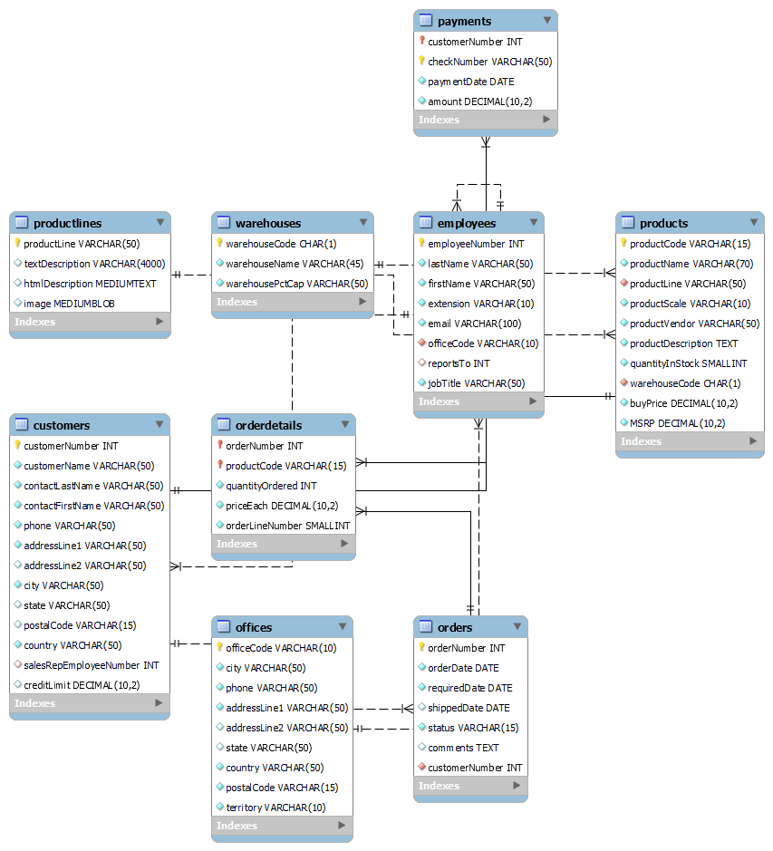

**INVESTIGATING THE BUSINESS PROBLEM**

**1) Where are items stored and if they were rearranged, could a warehouse be eliminated?**

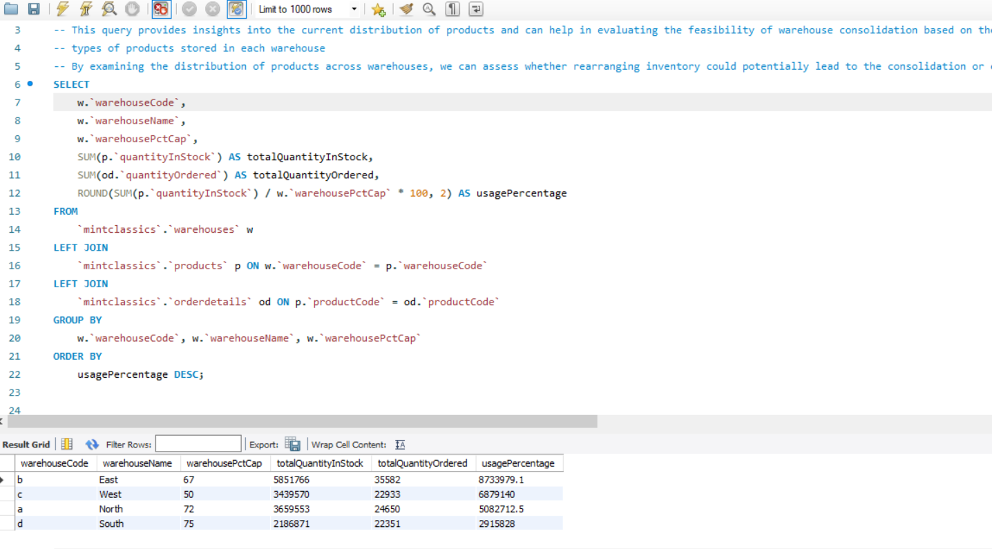

This query provides insights into the current distribution of products in each warehouse and can help in evaluating the feasibility of warehouse consolidation based on the volume and types of products stored in each warehouse.

1. **How are inventory numbers related to sales figures? Do the inventory counts seem appropriate for each item?**

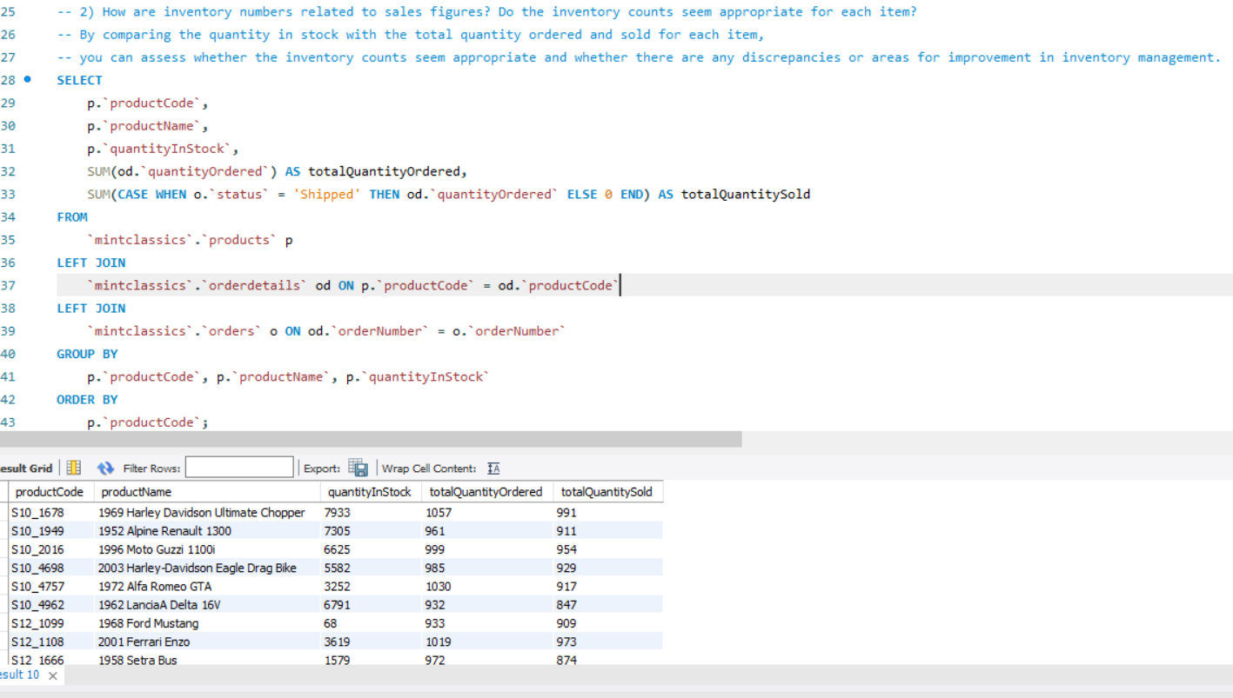

The total quantity ordered and total quantity sold are different for each product.

Some products have a high quantity in stock but relatively low total quantity ordered or sold.

Other products have a low quantity in stock but high total quantity ordered or sold.

Products with a high quantity in stock and low total quantity ordered or sold may indicate overstocking or slow-moving inventory.

The analysis highlights the importance of aligning inventory levels with sales figures to optimize inventory management and meet customer demand effectively.

1. **Are we storing items that are not moving? Are any items candidates for being dropped from the product line?**

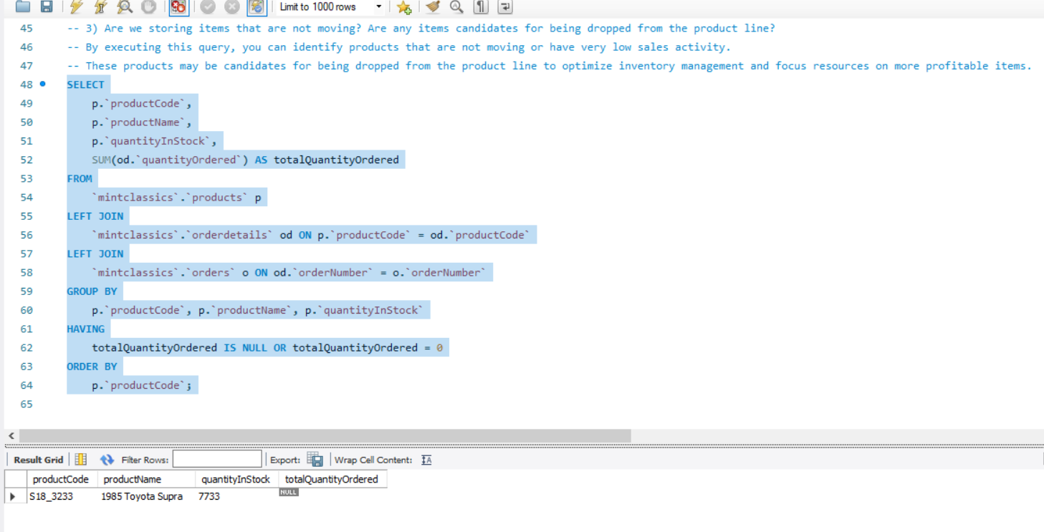

This query has identified the 1985 Toyota Supra as a product that is not moving. This product may be candidate for being dropped from the product line to optimize inventory management and focus resources on more profitable items.

**CONCLUSIONS AND RECOMMENDATIONS**

1. Closing the West Warehouse and Relocating Products:

The analysis reveals that the West warehouse has relatively lower revenue compared to other warehouses and houses several slow-moving or non-moving products.

Additionally, the inventory turnover rate for the West warehouse is lower compared to other warehouses, indicating inefficiencies in stock management and potential underutilization of warehouse space.

Therefore, I recommend closing the West warehouse and relocating its products to other warehouses, particularly those with higher revenue and better inventory turnover rates, such as the South and East warehouses.

This consolidation of inventory can lead to cost savings, improved inventory management, and potentially increased efficiency in order fulfillment processes.

1. Implementing Just-in-Time (JIT) Inventory Management:

The analysis highlights certain products with erratic demand patterns and slow-moving inventory across all warehouses.

To address this issue and optimize inventory levels, it is recommended to implement Just-in-Time (JIT) inventory management practices.

JIT inventory management focuses on minimizing inventory holding costs by synchronizing production with customer demand, thereby reducing excess inventory levels and associated carrying costs.

By adopting JIT principles, MintClassics can improve inventory turnover, reduce the risk of stock obsolescence, and enhance overall operational efficiency.